INSTITUTO POLITECNICO NACIONAL

Escuela Superior de Cómputo

Unit of learning

“Analog electronics”

Practice 9

“ Active filters”

Group: 1CV5

Integrants

* Konishi Govantes Jorge Agustín
* Luciano Espina Melisa
* Mena Ortiz Erick Jafet
* Ortega García Francisco Javier

INTRODUCTION 3

TEORICAL FRAMEWORK 3

OBJECTIVES 4

MATERIAL 4

EQUIPMENT 4

Experimental development 5

Filter spends falls 5

Filter spends discharges 6

Filter spends band 7

Photos 8

Questionnaire 9

Conclusions 10

Konishi Govantes Jorge 10

Luciano Espina Melisa 10

Mena Ortiz Erick Jafet 10

Ortega García Francisco Javier 10

# INTRODUCTION

A filter is an element that discriminates against a certain frequency or range of frequencies of an electrical sign that happens across him, being able to modify both his extent and his phase.

There are different types of classification of filters. Attending to the profit: passive Filters: those who will attenuate the sign in major or minor degree. They are implemented by passive components like condensers, bobbins and resistances. Active filters: they are those who can present profit in everything or part of the sign of exit with regard to that of entry. In his implementation operational amplifiers are in the habit of appearing. They are not in the habit of containing bobbins, except in case of very high frequencies. Attending to his response in frequency:

# TEORICAL FRAMEWORK

#### Filter spends falls

It corresponds to an electronic filter characterized for allowing the step of the lowest frequencies and attenuating the frequencies more altas.1 The filter needs of two terminuses of entry and two of exit, of a black box, also cuadripolo called or bipuerto, this way all the frequencies can appear at the entry, but to the exit alone there will be present those that the filter allows to spend. Of the theory there is obtained that the filters are characterized by his functions of transfer, this way any configuration of active or passive elements that obtain certain function of transfer they will be considered to be a filter of certain type.

A filter high step (HPF)

Is a type of electronic filter in whose response in frequency there weaken the componentes of low frequency but not those of high frequency, these even can amplify in the filters activos.1 The high or low frequency it is a relative term that will depend on the design and on the application.

#### A filter I spend band

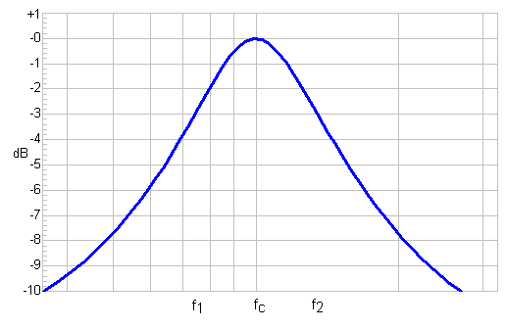It is a type of electronic filter that stops to spend a certain range of frequencies of a sign and to attenuate the step of the rest.

A simple circuit of this type of filters is a circuit RLC (resister, bobbin and condenser) in the one that is left to spend the resonance frequency, which would be the central frequency (fc) and frequency componentes next this one, in the graph up to f1 and f2. Nevertheless, it would be enough with a simple resonant network LC.

# OBJECTIVES

At the conclusion of the practice, the pupil will verify the functioning of the different types of filters I activate and it will determine the frequency of a filter determined across the extent of the sign of exit

# MATERIAL

* 1 Experimentation tablet operational (protoboard)
* 4 TL071 o LM741 (operational amplifier)
* 2 Resistors of 6.8KΩ a ¼ W
* 6 Resistors of 12KΩ a ¼ W
* 2 Resistors of 15KΩ a ¼ W
* 4 Resistors of 22KΩ a ¼ W
* 5 Capacitor 0.01µF a 50V
* 2 Capacitor 0.0022µF a 50V
* 3 Capacitor 0.047µF a 50V
* 2 Capacitor 0.0047µF a 50V

# EQUIPMENT

* Dual power supply +12 and -12
* digital multimeter
* function generator
* oscilloscope general purpose
* Coaxial cables with BNC terminal-Caiman
* 4 cables caiman-CAIMAN
* 3 BANANA leads-CAIMAN

# Experimental development

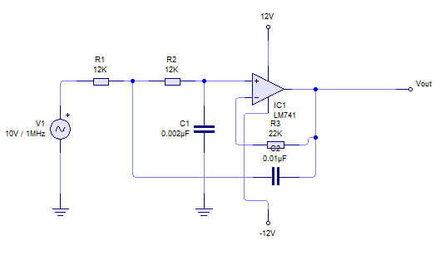

## Filter spends falls

Construct the following circuit that appears in the following figure, introduce a sign senoidal of 5Vpp in the terminus of entry. I changed the frequency of the generator to find the frequency of court of the circuit

Annotate the value of the frequency of court

Fc=

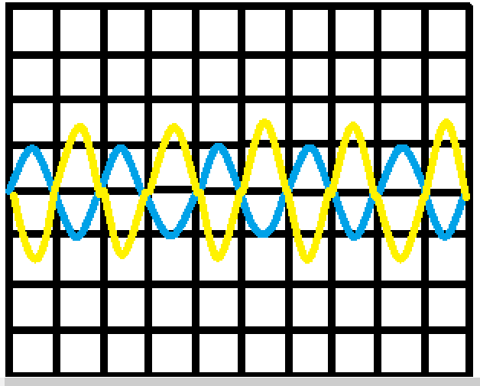**Draw the sign of court**

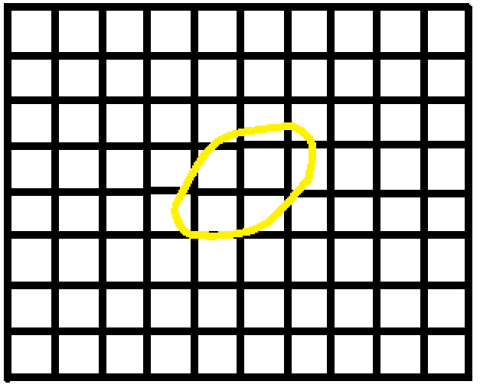**Change the format of the oscilloscope XY, I changed the frequency to 1 and draw the sign**

## Filter spends discharges

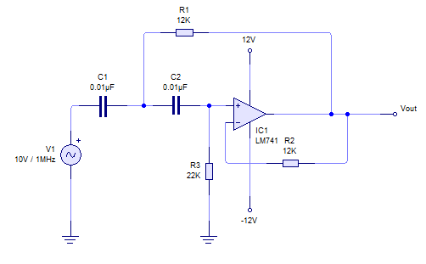

Construct the following circuit that appears in the following figure, introduce a sign senoidal of 5Vpp in the terminus of entry. I changed the frequency of the generator to find the frequency of court of the circuit

Annotate the value of the frequency of court

Fc=

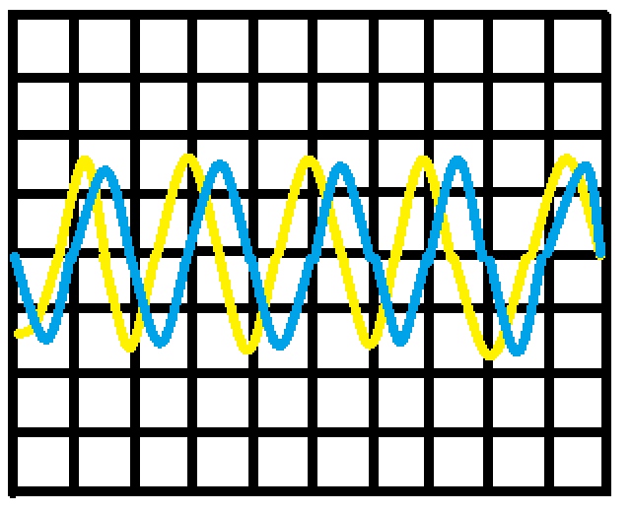**Draw the sign of court**

**Change the format of the oscilloscope XYand dra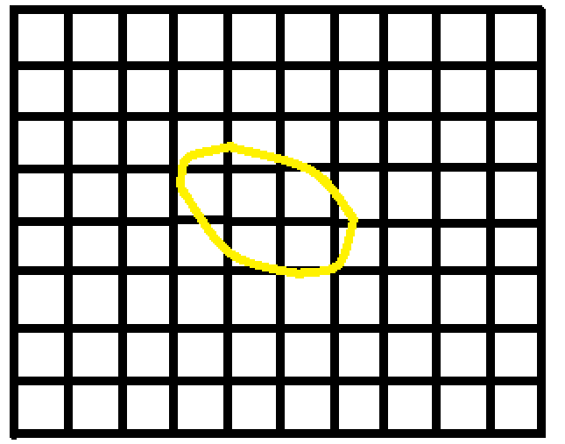w the sign**

## Filter spends band

Construct the following circuit that appears in the following figure, introduce a sign senoidal of 5Vpp in the terminus of entry. I changed the frequency of the generator to find the frequency of court of the circuit

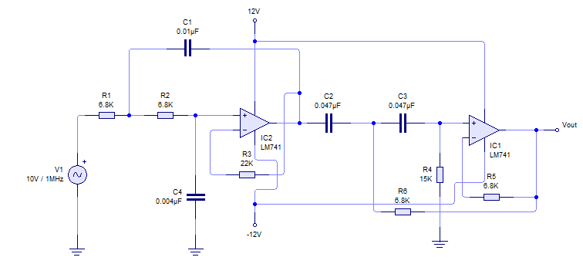

Annotate the value of the frequencies and determine the bandwidth

# Photos

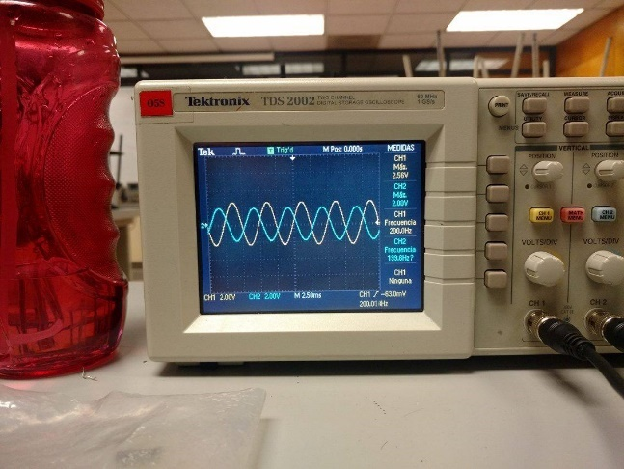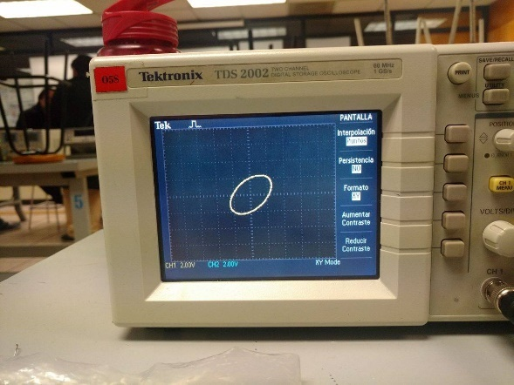

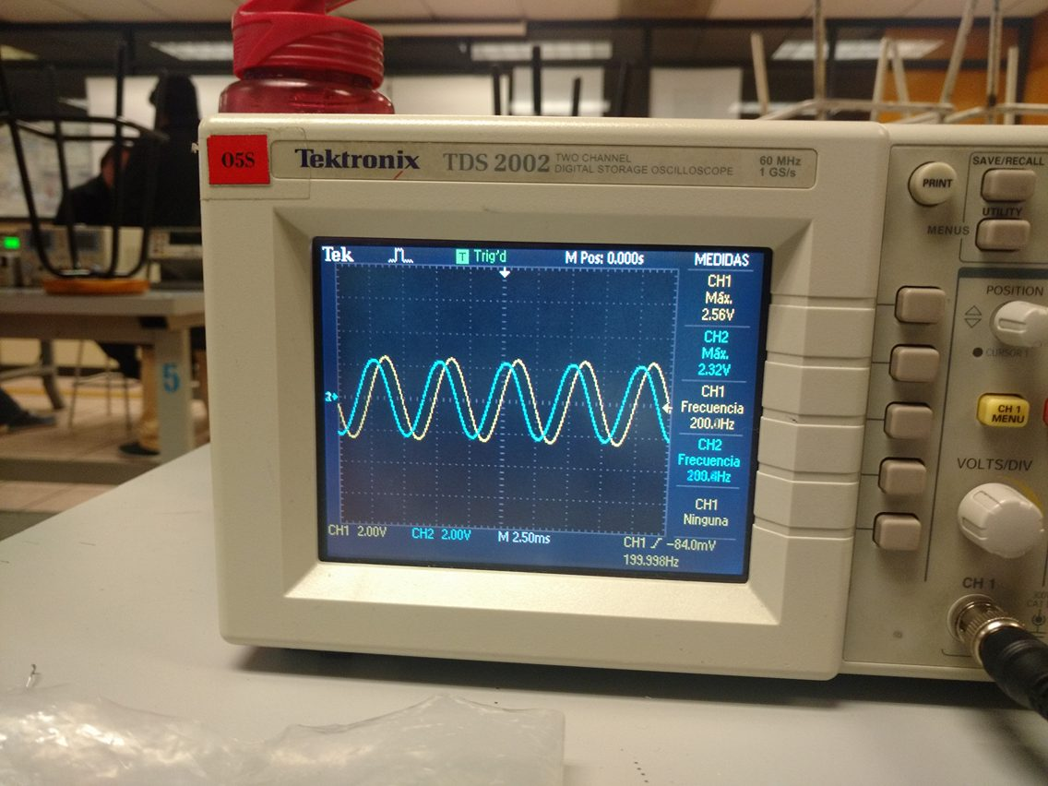

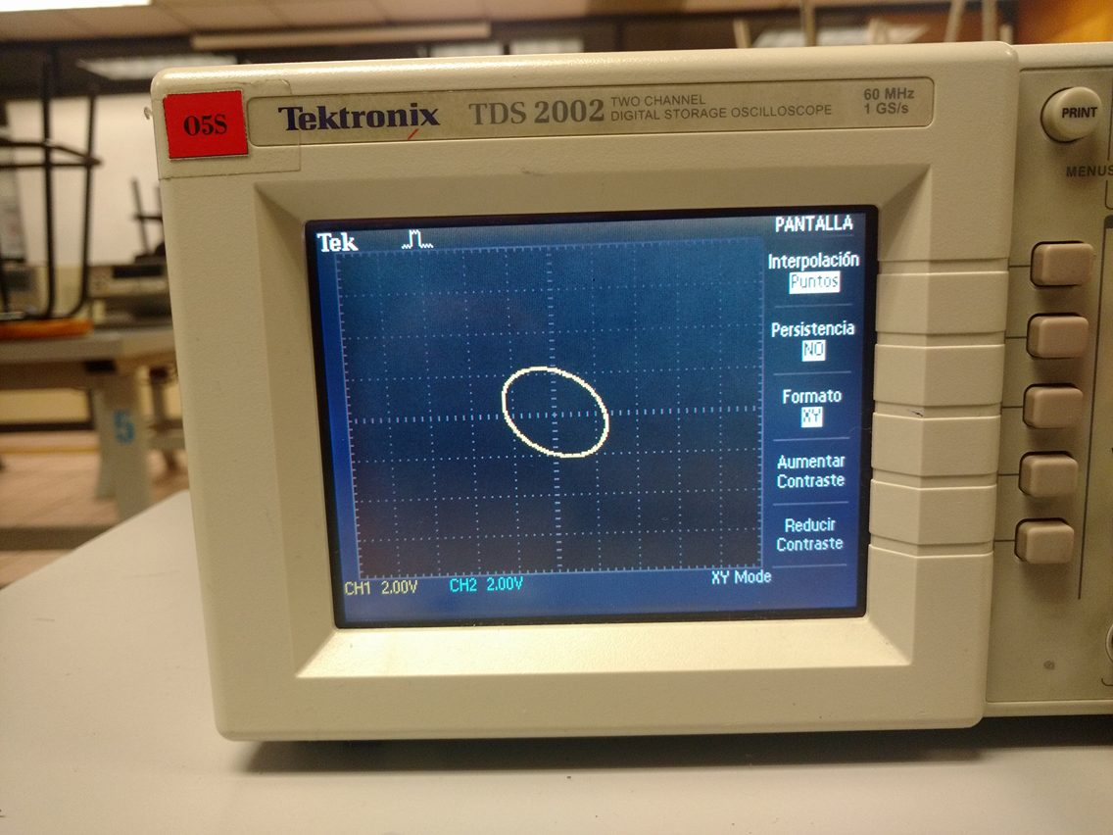

## Questionnaire

1. **What difference does exist between an active filter and a passive filter?**

The DC polarization is needed to establish the proper operating region for the amplification of AC.

1. **How does the frequency of court decide from the extent of the sign of entry and of exit of the circuit?**

The dc current gain of a transistor is the ratio of the dc current collector (IC) between the dc current base (IB) and is expressed as beta CD (βCD).



βCD typical values ranging from 20 to 200 or more.

1. **What is a filter of narrow band and what is a high-pass filter?**

The ratio of the dc current collector (IC) between the emitter dc current (IE) is the alpha cd (αCD). Alpha is a parameter that beta less used in circuits with transistors.



Generally αCD values ranging from 0.95-0.99 or more, although αCD is always less than 1. The reason is that IC is always slightly less than IE in an amount of IB.

1. **What goes on to him to the phase of the sign of exit with relation to the sign of entry?**

In the voltage divider circuit by large variations are not presented.

1. **What does us determine the order of the filter?**

The term polarization comprises everything related to the application of dc voltages, which help to establish a fixed level of current and voltage. For transistor amplifiers voltage and dc current resulting establish an operating point on the characteristics that define a region to be used for amplification of the applied signal.

Because the operating point is a fixed point on the characteristics, also called resting point (point Q abbreviated by the acronym of, quiescent point).

The bias circuit may be designed to set the device operation in either of these or other points within the active region. When the active region is confined many areas or different operating points can be selected.

# Conclusions

### Konishi Govantes Jorge

C Understanding how these devices I think is critical because many more complex circuits make use of transistors inside and know how they work from the basics allows the opportunity of entering more deeply into the subject and know that these circuits perform certain things.

### Luciano Espina Melisa

With this practice it was easier to visualize what in class I explain to him it brings over of the filters and also it was possible to observe the measurements, which were in conformity with the realized calculations

It is important to realize this type of practices since this way the functioning is understood more than each one of the filters

### Mena Ortiz Erick Jafet

The electronic filters have a very relevant function, and perform supreme importance since often they are used in the electronic circuits. They have the function to manipulate and modify the spectrum of frequency of the sign of entry to obtain in the exit the function that is needed to apply to the different circuits.

### Ortega García Francisco Javier

In developing this practice better I understand the operation of both NPN transistors and PNP, testing the various basic circuits which we can use for a particular purpose (fixed polarization splitter, etc).

On the other hand, I could see the changes both voltage and current in the transistor occurring with increasing temperature, making the visual effect of this on the device.

Now on the other side of the basic circuits, learn these different configurations help to know the changes that have one over the other, because it can be useful at some point and has more ideas in proposing a circuit with transistors.